Chapter – 11: Chemical Effects of Electric Current

# Static Electricity

* Remove synthetic clothes – hear crackling sound – if its dark – tiny sparks visible
* Woollen, synthetic clothes – gets charged – rubbed against skin – static electricity
* Walk on thick nylon carpet – touch a metal door – same effect
* 1st observed – Thales – Greek scientist – 2500 years ago
  + Noticed – amber rubbed with silk – tiny feathers attracted
* Activity –
  + Take a comb – rub it in your hair – tiny pieces of paper attracted

# Electric Charges

* Rub 2 things together – both gets charged – opposite charges
* 2 types of charges – positive (+) and negative (-)
* 18th century – American scientist – Benjamin Franklin – realized these charges
* Universe – everything made of tiny atoms – all persons, chairs, tables, food, air, etc
* Each atom – charged particles – middle of atom – nucleus – positive charge (protons)
* Negative charge (electrons) – revolve around protons
* Like solar system – electrons like planets – revolve around – proton like sun
* Atoms – uncharged – remain neutral – balance between positive and negative charges
* This balance – disturbed – atoms – charged particles
* 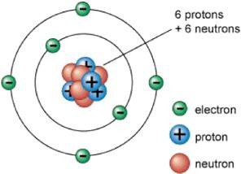Atom – loses electron – positive charge – gains electron – negative charge

# Charging of Bodies

* Charged by –
  + Friction –
    - One body – rubbed on other – different materials – transfer of charges
    - This energy – frictional electricity
    - Rub flannel over glass rod – flannel – negative – glass rod – positive
  + Conduction –
    - Neutral body – touches charged body – charges transfer
  + Induction –
    - Neutral body brought near charged body – electrons in neutral body – forced to move
    - This energy – induced electricity
* Charged bodies – following properties – fundamental laws of charges at rest
  + 2 types of charges – positive and negative – charged body attracts neutral body
  + Like charges – repel – unlike charges – attract
* Repulsion – sure test – determine (check for) charge
* Activity –
  + Take 2 balloons, 2 piece of threads, a woollen cloth, 1 broom handle
  + Blow up the balloons – hang them from broom handle
  + 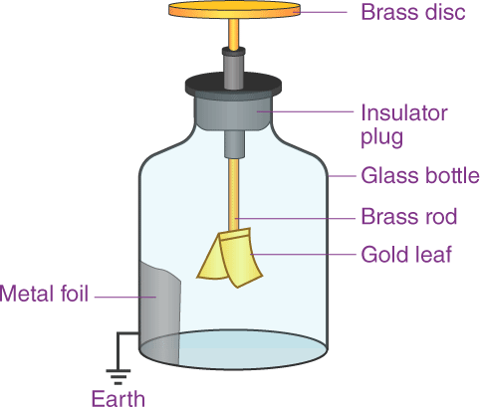Rub the balloons – woollen cloth – repel each other

# Electroscope – Charging by Conduction

* Device – detect, test – small charges
* Consists – metallic rod, metallic disc or cup
* Foot of the rod – metal plate – thin metal leaves
* Rod – held by insulating plug – transparent case – protect the leaves
* Rub glass rod – silk cloth – touch the disc
* Charges – transferred to metal leaves – they diverge (move away from each other)

# Electric Current and Conductivity

* Flow of charge – electric current or electricity
* Electricity – most convenient, flexible energy
* Generated, stored, distributed – easily
* Easily convertible – heat, light, sound, energy
* Many practical applications – lives of people – changed so much
* Industrialised countries – people – use many electric devices
* Many materials – conduct electricity – allows electricity to pass
* How much conduction – depend on conductivity
* Conductors –
  + Materials – allow electricity to flow – easily
  + All metals, graphite, etc
* Insulators –
  + Materials – do not allow electricity to flow
  + Rubber, wood, glass, etc

# Conduction in Liquids

* Conduct electricity – metals require – lots of mobile (moving) electrons
* Some liquids – conduct electricity

## Conductivity of water

* Pure, distilled water – mobile electron – no conduction
* Add some table salt – conductivity changes
* Tap water – added chemicals – conduct electricity
* Never use, touch – electrical devices – near water or with wet hands
* Electric current – may pass through body – electric shock
* Activity –
  + Fill a beaker – distilled water – make a circuit – instead of switch – dip both free ends in water – bulb does not glow
  + 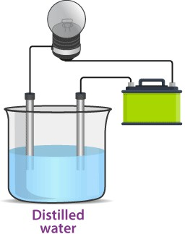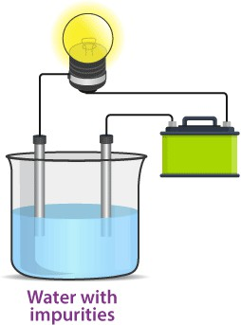Dissolve some salt – bulb starts to glow

## Conductivity of other liquids

* Other liquids – also conduct electricity
* Many liquids – lemon, vinegar – conduct electricity – good conductors
* Some liquids – cooking oil, kerosene – bad conductors
* Bad conductors – may conduct electricity – specific conditions
* Sometimes – liquids – conduct electricity – not that good – bulb does not glow – weak electric current
* In such case – use LED – instead of bulb
* LED – works in weak current – 2 long wires – unequal lengths – longer one – connected to positive battery terminal – shorter one – connected to negative battery terminal

# Chemical Effects of Current

* Electric current – through liquids – chemical action – electrolysis
* Example – water – current passed – breaks into hydrogen and oxygen
* Liquid – contains metals – electrolysis – breaks up solution – metal removed
* This process – useful – coating metal on objects – refining, purifying metals
* Liquids – break up into charges particles – conduct electricity – electrolytes

## Process of electrolysis

* 2 solid electrical conductors – metal or graphite rod – placed in electrolytic solution
* These rods – electrodes – connected to battery
* Electrolyte – allows electric current to flow
* Electrode – connected to negative battery terminal – cathode – carries electrons – battery to solution
* Electrode – connected to positive battery terminal – anode – carries electrons – solution to battery
* Reaction – depends on – electrodes, electrolytes

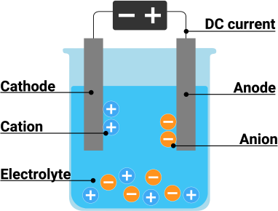

## Electrolysis of copper sulphate solution

* Copper plates – used as electrodes
* Current – passed through copper sulphate – divides into copper ions, sulphate ions
  + CuSO4 → Cu2+ + SO 2-

4

* At anode – copper metal – lose electrons – produce copper ions
  + Cu → Cu2+ + 2e-
* Positive copper ions – move to cathode – gain electrons – deposit there
* Loss of copper in solution – equal copper dissolved in solution
* This way – entire anode – dissolved in solution
* Sulphate ions – does not take part – copper – keeps depositing on cathode
* This process – used for purification
* Electrolysis – used for many things – production and purifying
* Example – electrolysis of Sodium Chloride (NaCl) – produce caustic soda

# Electroplating

* Deposit layer of metal on another metal – surface more decorative, resistant to corrosion – electroplating
* Steel – strong metal – used for many things
* BUT – steel rusts – protect by covering it with something
* Either paint it – OR – coat chromium on it – chromium plating
* Electroplate spoon with silver – dissolve Silver Nitrate (AgNO3) in water
* Spoon – connected to negative terminal – become cathode
* Silver bar – attached to positive terminal – become anode
* Current passed into solution – divides into silver ions (positive) and nitrate ions (negative)
* Silver ions – attracted by spoon – sticks to it
* Nitrate ions – attracted by anode – silver bar
* Loss of silver – silver dissolved from bar to solution
* This process – continue till spoon is covered in silver
* 2 main advantages –
  + Protects metal from corruption
  + Provides shiny finish to surface
* Uses –
  + Manufacture – PCB (printed circuit board) – televisions, computers, etc
  + 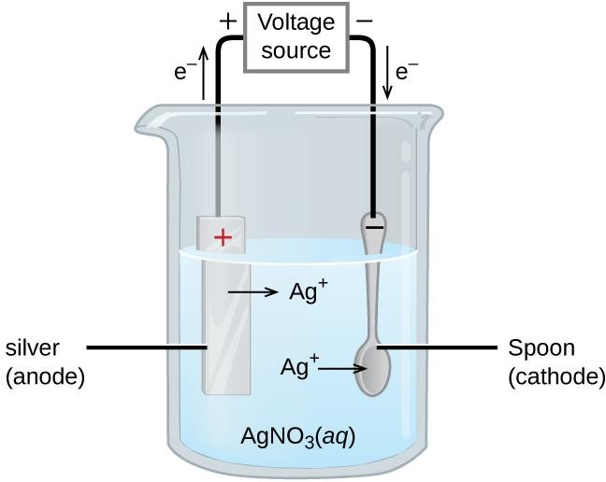Jewellery – made of cheaper materials – coated with gold, silver
  + Water taps – electroplating – looks shiny – protected from rusting, wear and tear
  + Cans – made of iron – may react to food – coated with tin
* Electroplating – done in many factories – waste product disposed – very harmful